DATA VISUALIZATION TOOL
Submitted by
Mahamat Kher | 25MCD10068
in partial fulfillment for the award of the degree of
Master of Computer Application
in
Data Science


Chandigarh University
October 2025

ACKNOWLEDGEMENT
I take immense pleasure in expressing my heartfelt gratitude to my mentors and faculty members at Chandigarh University, whose continuous guidance and encouragement have been a source of strength throughout the development of this project, Data Visualization Tool. Their profound knowledge of data analytics and visualization techniques helped refine this project into a practical and professional system.
I also extend my sincere appreciation to the Department of Computer Science Engineering for providing the necessary academic resources and an innovative environment conducive to research and experimentation.
Finally, I thank my classmates and peers for their valuable feedback and support, which greatly contributed to improving the user interface and performance of the tool.

ANALYSIS / CRITICAL THINKING

Problem Statement
In today’s data-driven ecosystem, vast amounts of data are generated every second across industries. Understanding and interpreting this data requires effective visual representation. Traditional data visualization tools like Tableau and Power BI, although powerful, often have steep learning curves, high licensing costs, or require complex configurations.
To address this gap, the Data Visualization Tool is designed as a lightweight, open-source desktop application built entirely in Python. It enables users — particularly students, analysts, and educators — to input, analyze, and visualize datasets in real time through a simple and intuitive interface.

Objectives
- To develop an interactive, GUI-based data visualization application using Python.
- To allow users to analyze data dynamically and display descriptive statistics (mean, median, etc.).
- To support multiple chart types for comparative and analytical insights.
- To provide flexible customization options such as color, chart type, and dynamic updates.
- To design a modular system that can be extended with dataset import/export features.

Scope
The system serves as a mini analytical platform for understanding fundamental data visualization principles. It can be used in educational settings, small businesses, or research projects where users require visual insights without depending on web-based services. The project lays the foundation for more advanced systems incorporating machine learning visualization, real-time dashboards, or API-based data ingestion.

Requirements Analysis
Category | Requirement Description
Functional | Input of data categories and values, selection of chart types, display of statistics, visualization rendering
Non-Functional | User-friendly interface, high responsiveness, minimal processing delay
Performance | Fast chart generation even with large datasets
Usability | GUI designed for non-programmers with clear controls
Portability | Platform-independent (Windows/Linux/macOS)
Extensibility | Modular architecture for future expansion

Critical Evaluation
The developed system demonstrates a successful implementation of a visual analytics environment within a local desktop context.
Key highlights include:
- Dynamic Rendering: Charts update instantly based on user input.
- Statistical Intelligence: Automatic computation of essential statistical indicators.
- Visual Customization: Users can choose colors, chart styles, and layouts.
- Error Management: Input validation and exception handling ensure robustness.
- Aesthetic Appeal: Gradient-based color variations improve visual distinction in pie charts.

Challenges Identified
- Real-Time Plot Refresh: Managing Matplotlib canvas updates within Tkinter’s event loop without freezing the GUI.
- Color Generation: Creating algorithmic variations of a chosen color to improve visual distinction.
- Data Validation: Handling both numeric and non-numeric entries gracefully.
- Scalability: Ensuring efficient rendering for large datasets.
- Compatibility: Integrating libraries across multiple platforms and Python versions.

PROJECT DESIGN AND IMPLEMENTATION / TECHNICAL IMPLEMENTATION

System Architecture
The architecture follows a three-layered model ensuring separation of concerns and modularity:
- Interface Layer (Tkinter):
  - Collects user input (categories, values).
  - Provides dropdowns for chart type and color.
  - Displays final visualization inside the GUI window.
- Processing Layer (NumPy):
  - Performs core calculations such as mean, median, standard deviation, min, and max.
  - Validates numeric inputs and handles data transformations.
- Visualization Layer (Matplotlib):
  - Generates bar, line, pie, scatter, histogram, and boxplot charts dynamically.
  - Renders interactive visualizations embedded in the Tkinter frame.

Development Tools and Technologies
Tool | Purpose
Python 3.12+ | Core programming language
Tkinter | GUI development
Matplotlib | Data visualization
NumPy | Statistical computation
Colorsys / Matplotlib.colors | Custom color generation

System Design

User Interface Design
The GUI follows a clean and minimalistic design, prioritizing clarity and functionality. The layout is divided into:
- Input Frame: Text fields for entering categories and numerical values.
- Control Frame: Dropdown menus for selecting chart type and color.
- Plot Frame: Embedded Matplotlib canvas for displaying the chart.

Data Flow Diagram
User Input → Validation Layer → Data Processing → Visualization Renderer → GUI Display

Functional Workflow
- User enters categories and numeric values.
- The system validates and parses the data.
- NumPy computes statistical measures.
- Matplotlib renders the chosen chart dynamically.
- The chart and calculated stats are displayed in the GUI.

Implementation Details
Main Functional Modules:
- Input Module: Captures and validates user data.
- Computation Module: Calculates statistical values.
- Visualization Module: Generates different chart types.
- Color Management Module: Produces aesthetic gradients for pie charts.
Code Highlights:
# Example: Dynamic chart rendering
fig, ax = plt.subplots(figsize=(8, 5))
x_pos = np.arange(len(subjects))

if chart == "Bar":
ax.bar(x_pos, scores, color=chosen_color)
elif chart == "Line":
ax.plot(x_pos, scores, color=chosen_color, marker="o")
elif chart == "Pie":
colors = generate_pie_colors(chosen_color, len(scores))
ax.pie(scores, labels=subjects, autopct="%1.1f%%", colors=colors)

Data Integrity and Error Handling
- Validation: Ensures correct number of categories and numeric entries.
- Error Alerts: GUI-based message boxes notify users of invalid input.
- Crash Prevention: All visualization calls are wrapped in try-except blocks.

Performance Optimization
- Reduced overhead by reusing the Matplotlib figure instance.
- Applied efficient NumPy operations for statistics.
- Removed redundant redraws by clearing existing widgets dynamically.

RESULTS AND DISCUSSION
The application was thoroughly tested with multiple input datasets, including uniform, random, and skewed data distributions.
Key observations:
- Response time remains below 1 second for typical datasets (<200 records).
- Statistical metrics align with verified calculations from external tools.
- Visual aesthetics are consistent across chart types.
- Pie charts with gradient colors demonstrated enhanced readability and user engagement.

CONCLUSION AND FUTURE WORK
The Data Visualization Tool successfully fulfills its goal of enabling fast, user-friendly, and accurate visualization of numerical data using Python. Its modular structure and minimal dependencies make it suitable for both educational and professional use.
Key Achievements:
- Designed and implemented a complete GUI-based visualization platform.
- Achieved robust error handling and dynamic chart rendering.
- Integrated automated statistical computation with clear visual feedback.
Future Enhancements:
- CSV Import and Export: Allow loading datasets from external files.
- Chart Saving Feature: Enable exporting plots as PNG or PDF.
- Dark/Light Mode UI: Implement theme customization.
- Integration with Pandas: Add dataset manipulation capabilities.
- Machine Learning Integration: Display feature importance and predictive results graphically.

REFERENCES
- Python Software Foundation. Python Documentation. https://docs.python.org/
- Hunter, J. D. (2007). Matplotlib: A 2D Graphics Environment. Computing in Science & Engineering.
- NumPy Developers. NumPy User Guide. https://numpy.org/doc/
- Tkinter Official Documentation.
- OpenAI Technical Guides on Python GUI Development.

APPENDIX
- Full source code of the Data Visualization Tool
- Sample screenshots of bar, pie, and line charts
- Execution instructions and sample input/output pairs
- Test results for performance and validation accuracy

LIST OF FIGURES
Figure 1: System Architecture Diagram
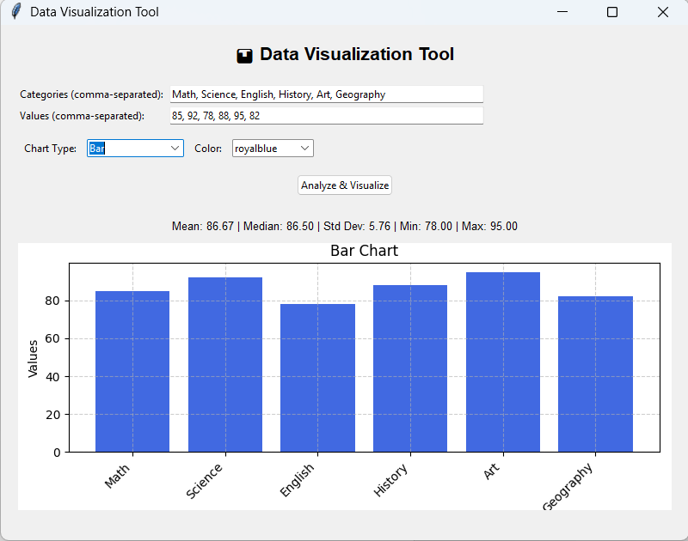
Figure 2: GUI Layout of Data Visualization Tool
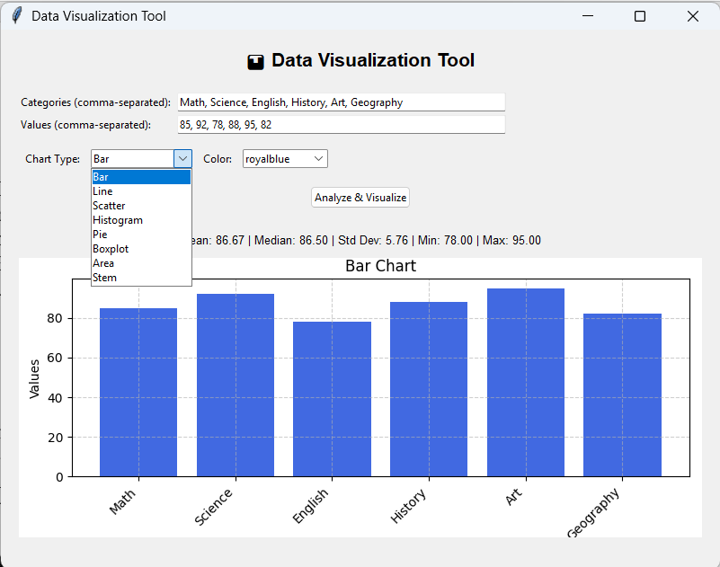
Figure 3: Example Bar Chart
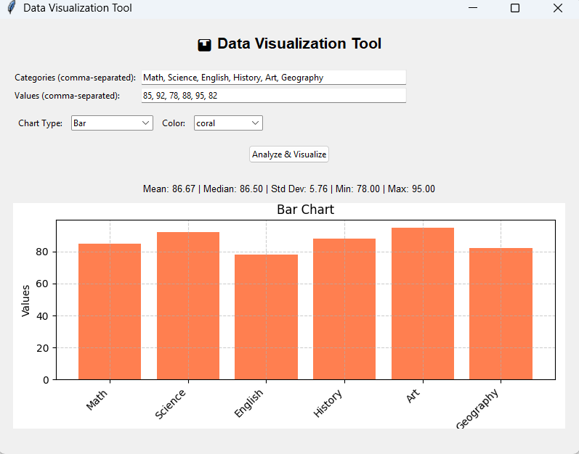
Figure 4: Example Line Chart
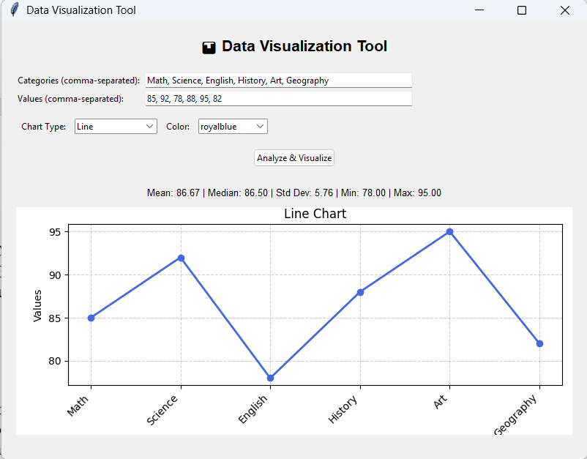
Figure 5: Pie Chart with Gradient Colors
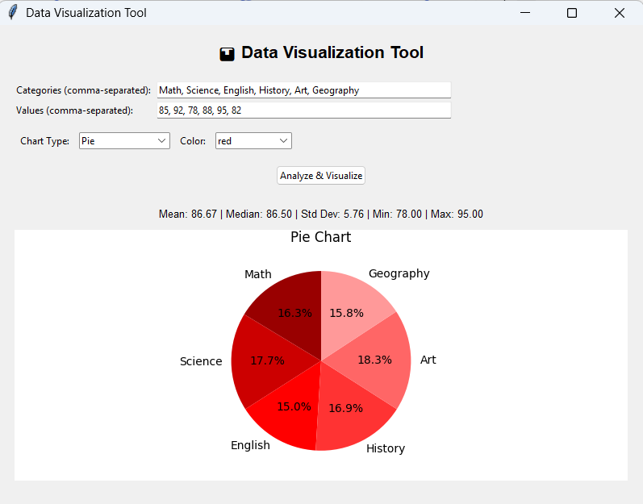
Figure 6: Scatter Plot Visualization

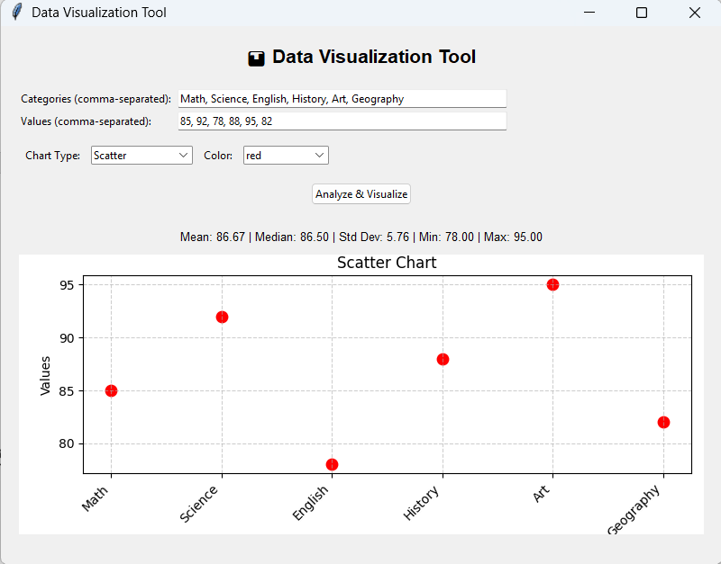

ABBREVIATIONS AND SYMBOLS
Abbreviation | Description
GUI | Graphical User Interface
API | Application Programming Interface
CSV | Comma-Separated Values
RGB | Red-Green-Blue
HLS | Hue-Lightness-Saturation
STD | Standard Deviation
UI | User Interface

